Jenkins-assignment 10A:
Build and package LoginWebApp .war file on Jenkins Master and deploy on slave (Tomcat already running)
------------------------------------------------------------------------------------------------------------------
Running job on built-in node
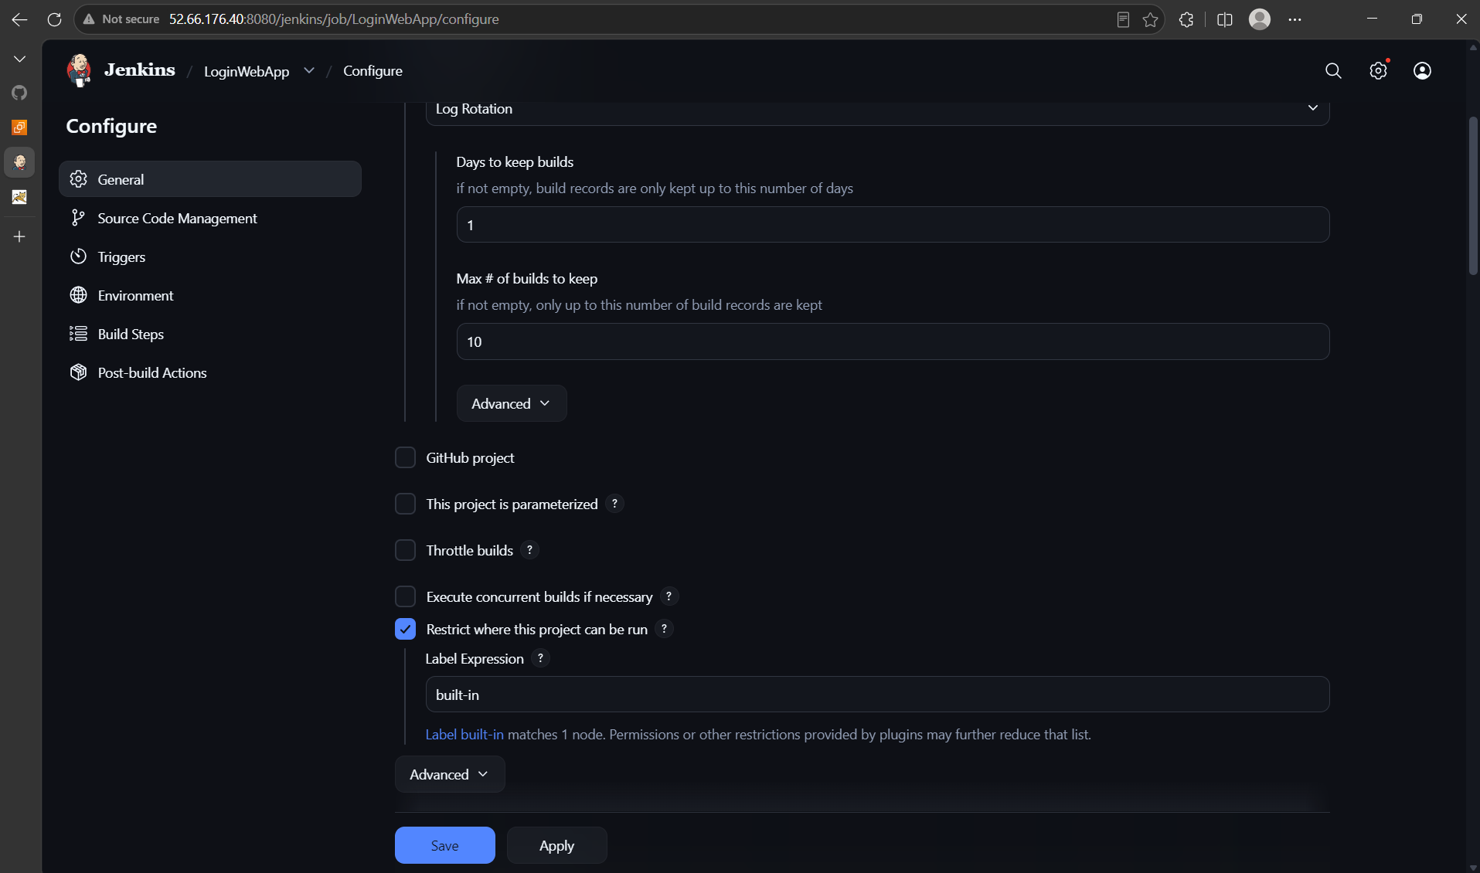
Cloning LoginWebApp.git Repository
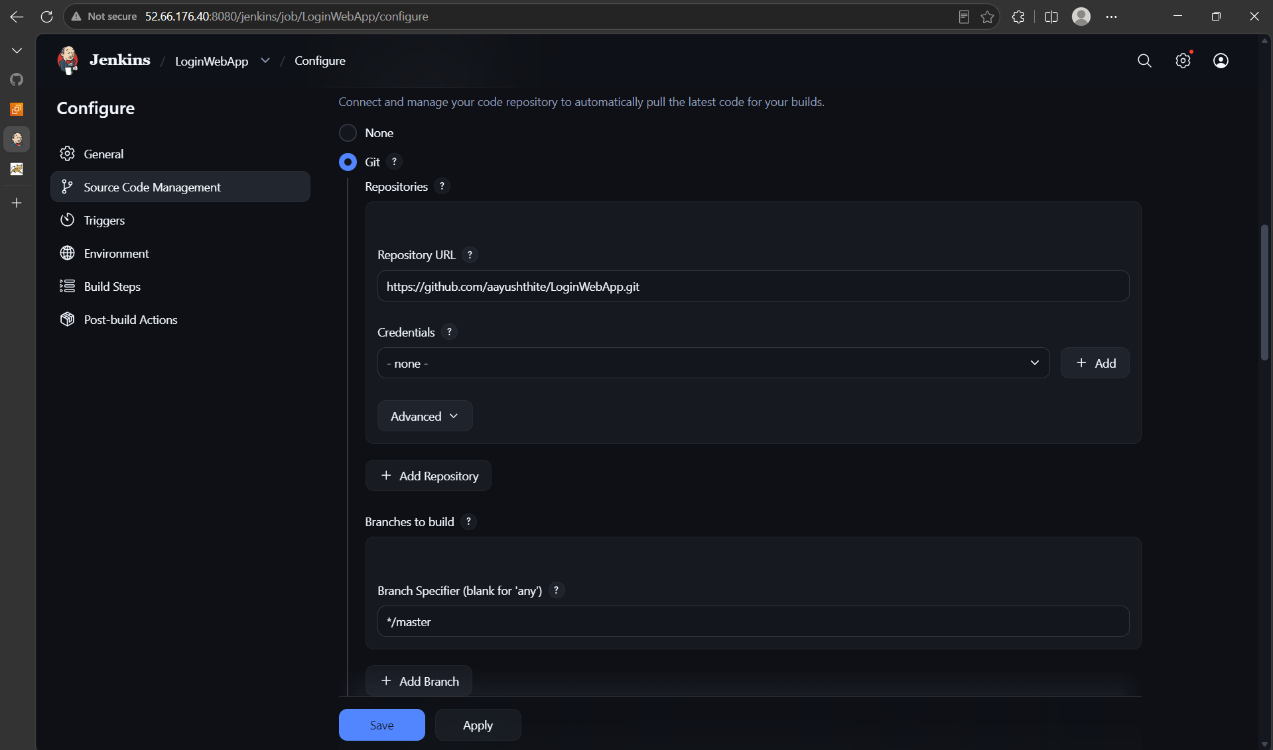
Invoke maven targets for clean package
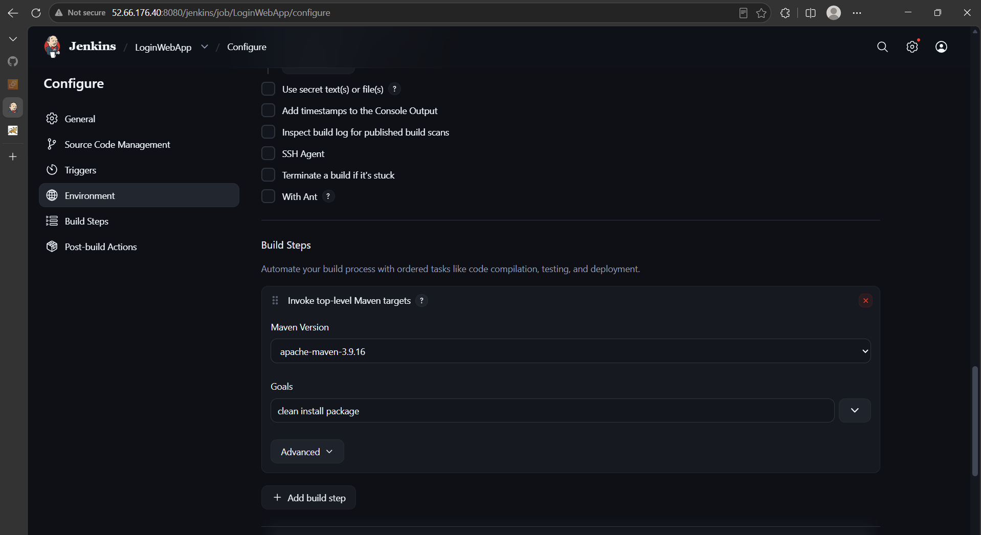
Archive .war file in Jenkins workspace and trigger new job for slave deployment as downstream only after stable build
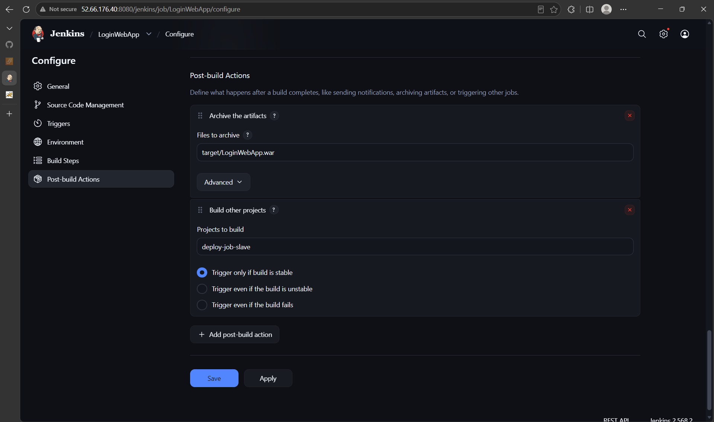
Store .war files in Jenkins Masters build workspace
Here I have used Copy Artifact Plugin
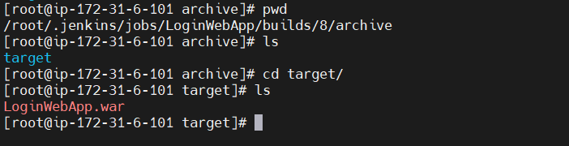
Build Successful
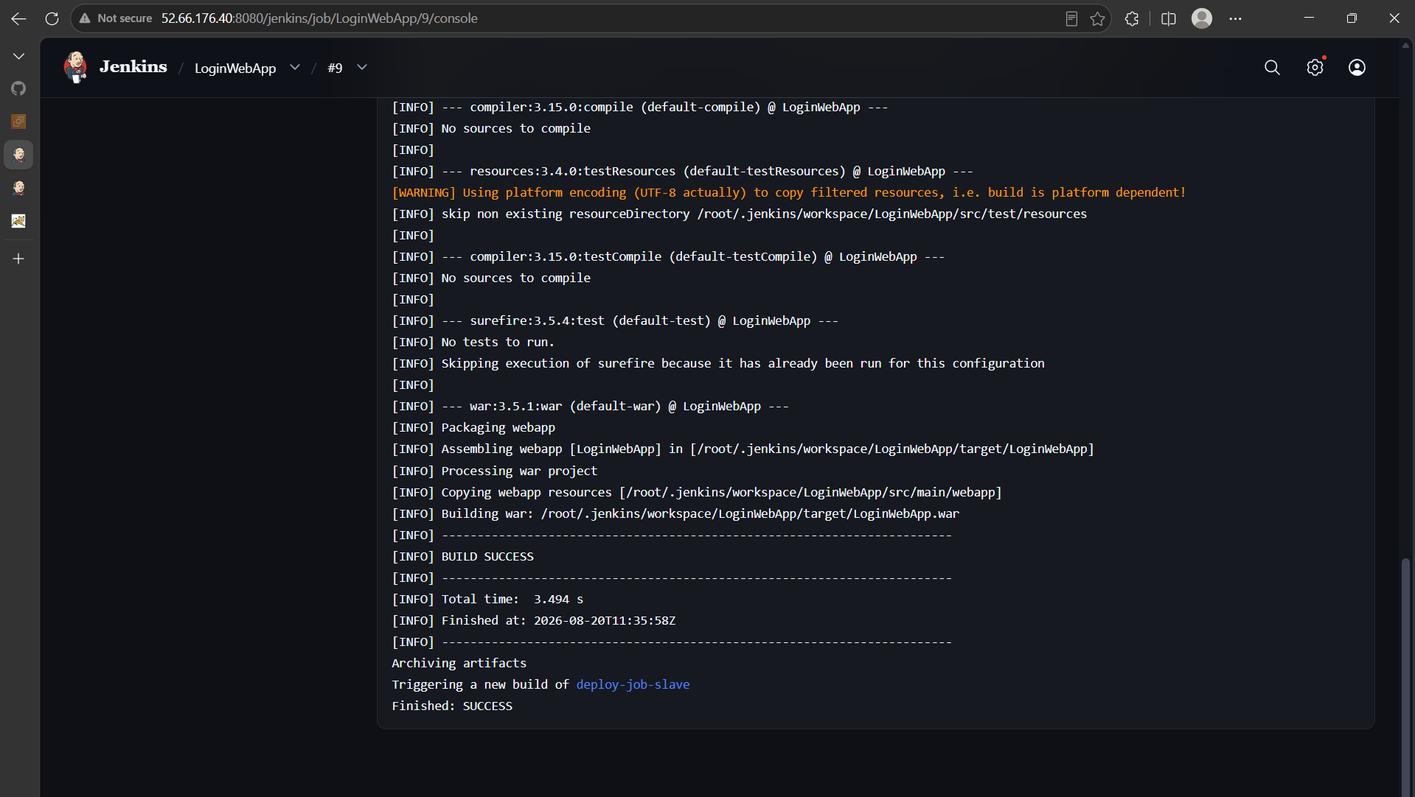
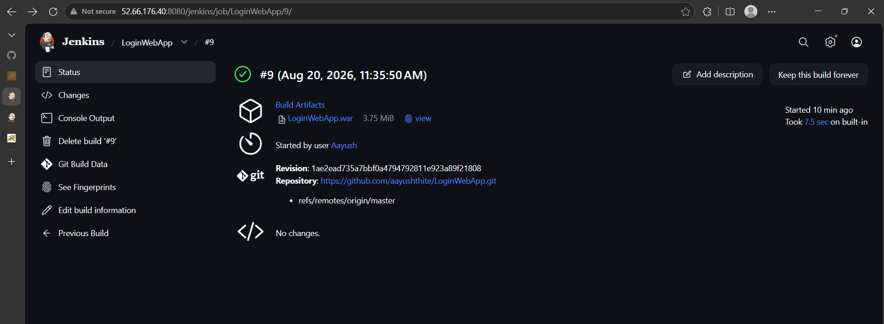
Now this 2nd job will run on slave 1 and deploy .war file
